Dokumentasi Rifqi

Buat tombol di pojok kanan atas untuk ke screen pengaturan

Buat screen baru pengaturan yang bisa mengatur mode gelap

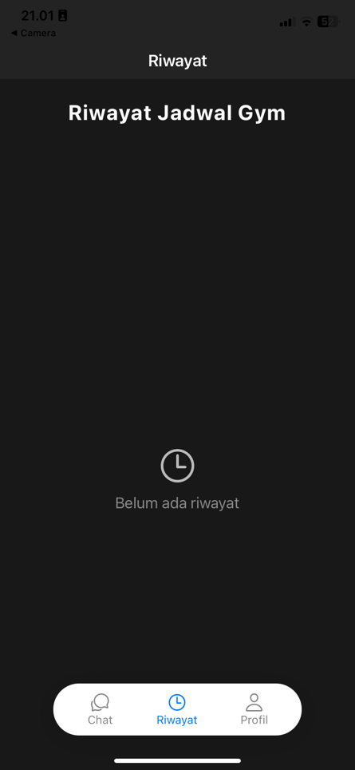 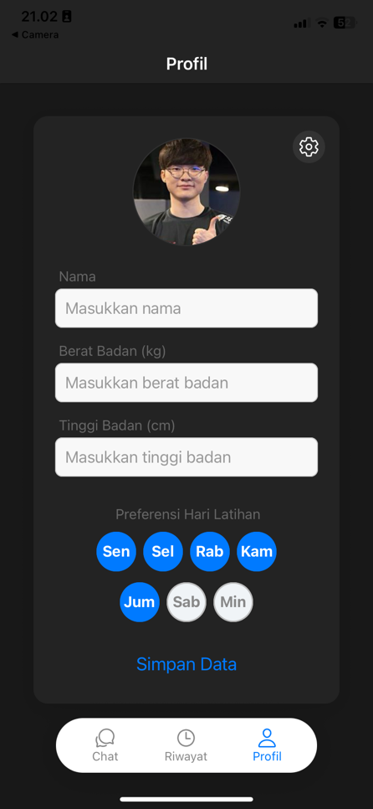

Pengaturan Mode Gelap

Pengaturan Bahasa